
COMSATS UNIVERSITY ISLAMABAD
Name : Arafat Khan

Roll No : FA25-BDS-013

SUBMITTED TO: Mr. Khurram Iqbal

Date : 15 September 2025

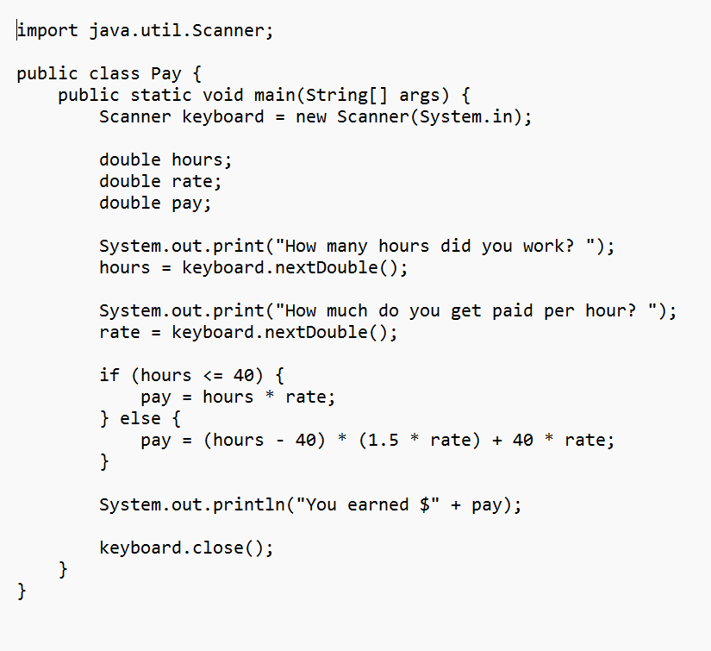
CODE FOR PAY CALCULATOR
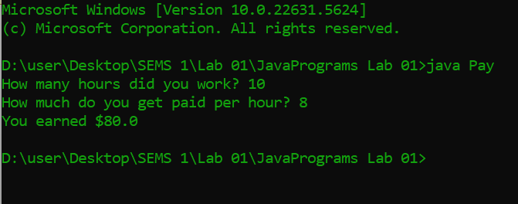
Executing the Code

 |  | Pay Calculation Results
Hours | Rate | Pay( hand Calculated ) | Pay (Program Result)
10 | 12 | 120 | 120
12 | 10 | 120 | 120
8 | 10 | 80 | 80
20 | 8 | 160 | 160

